**UNIX ASSIGNMENT**

1. TAR

tar is to simply combine a few files into a single file, for easy storage and distribution.

* **z:** option tells **tar** to zip the archive as it is created.
* **x:** (**extract**) in present working directory
* c: **Creates a new .tar archive file.**
* **v: In create and extract modes, tar will list each file name as it is read from or written to the archive. In list mode, tar will produce output similar to that of ls(1).f Read the archive from or write the archive to the specified file.**
* r: add file named file1 to existing file.tar

**Problems Solved**

**Creating compressed version of files. Thus useful to transfer files as it takes less space.**

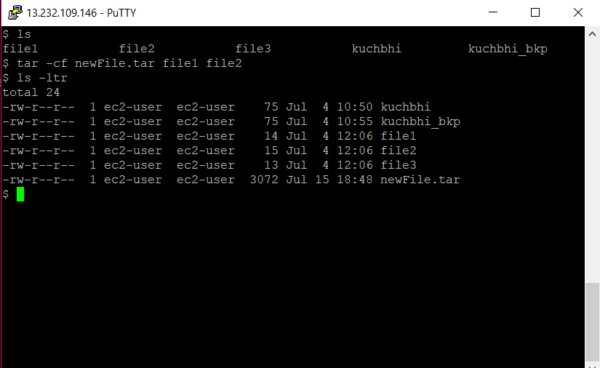

1. **Find**

Find (.) search the specified file within current directory and sub directory.

- E Interpret regular expressions followed by -regex and –iregex

- d Cause find to perform a depth-first traversal.

- s Cause find to traverse the file hierarchies in lexicographical order, i.e., alphabetical order within each directory.

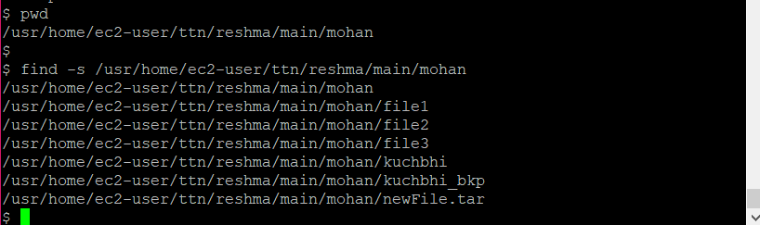

1. **Locate**

Finds file names quickly.

It is comparatively faster than find.

Case insensitive file searching was made much easier.

-S Print some statistics about the database and exit.

-c Suppress normal output; instead print a count of matching file names.

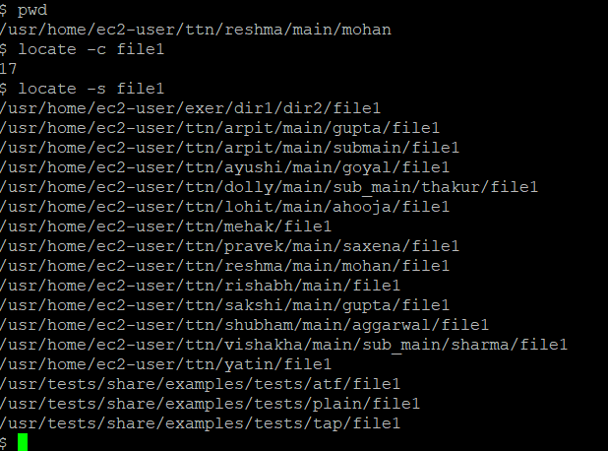

1. **DIFF**

It is a command which compares file line by line with an additional advantage, i.e., it tells the line number and instructions that are to be followed to make two files identical.

To find the difference between two files.

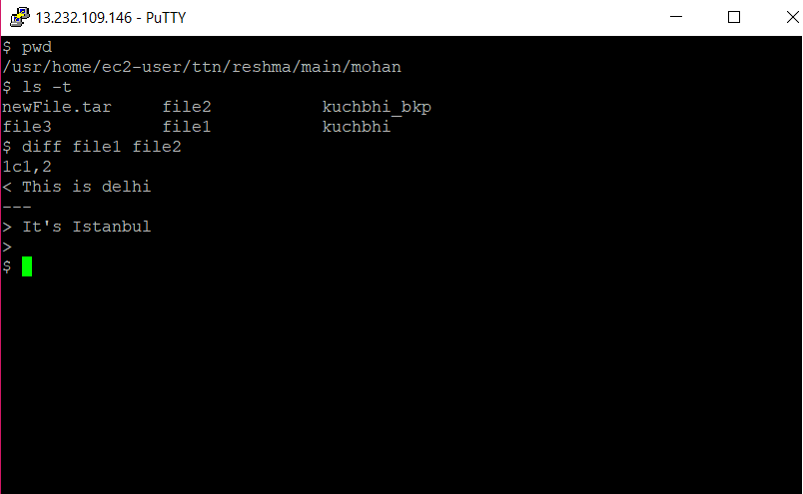

1. **TAIL**

display the last part of a file

-b number, --blocks=number

-c number, --bytes=number

-f the -f option causes tail to not stop when end of file is reached, but rather to wait for Additional data to be appended to the input.

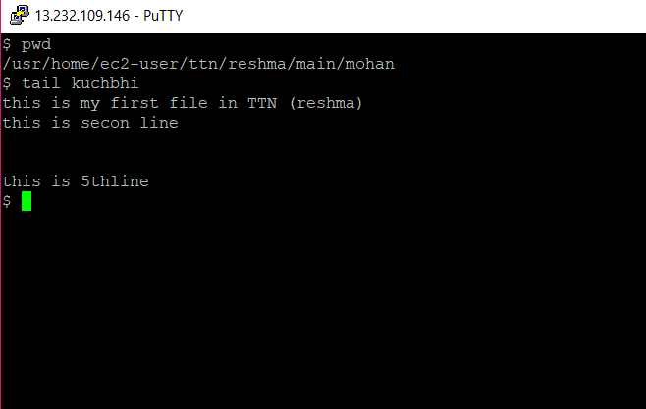

1. **LESS**

Less is a program similar to more, but which **allows backward movement** in the file as well as **forward movement**.

Also, less does not have to read the entire input file before starting, so with large input files it starts up **faster** than text editors like vi.

command is used to view files instead of opening the file.

